Date: 25/07/25
Roll No. and Name: 24BCE174 and Khush Pithva
Course Code and Name: 2CS502CC25 and Object Oriented Programming
Practical No: 4(a)
AIM: Write a program to accept 10 integers in an array and print
them in reverse order

Methodology followed:
#include<bits/stdc++.h>
using namespace std;

int main()
{
int arr[10];

cout<<"Enter 10 element of array : ";
for (int i = 0; i < 10; i++)
{
cin>>arr[i];
}

cout<<"Elements in reverse order:"<<endl;
for (int i = 9; i >= 0; i--)
{
cout<<arr[i]<<" ";
}

return 0;
}

Output:
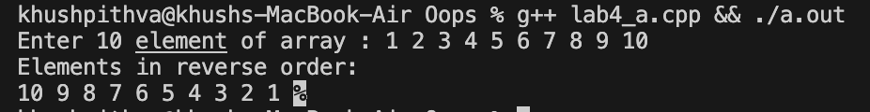
Practical No: 4(b)
AIM: Develop a program to find the second largest number in a
user-defined array.
Methodology followed:
#include<bits/stdc++.h>
using namespace std;

int main()
{
int n;
cout<<"Enter the size of array";
cin>>n;
int arr[n];
cout<<"Enter "<<n<<" integers: "<<endl;
for (int i = 0; i < n; i++)
{
cin >> arr[i];
}
int large=INT_MIN;
int slarge=INT_MIN;

for (int i = 0; i < n; i++)
{
if (arr[i] > large)
{
slarge = large;
large = arr[i];
}
else if (arr[i] > slarge && arr[i] != large)
{
slarge = arr[i];
}
}
cout << "The second largest number is: " << slarge << endl;
return 0;
}
Output:
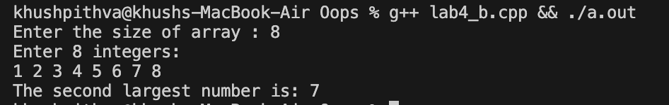
Practical No: 4(c)
AIM: Create a program to merge two arrays of integers into a third
array and display it

Methodology followed:
#include <bits/stdc++.h>
using namespace std;

int main()
{
int n, m;
cout<<"Enter the size of first array: ";
cin>>n;
int a[n];
cout<<"Enter the elements of first array: ";
for (int i = 0; i < n; i++)
{
cin>>a[i];
}

cout<<"Enter the size of second array: ";
cin>>m;
int b[m];

cout<<"Enter the elements of second array: ";
for (int i = 0; i < m; i++)
{
cin>>b[i];
}

int finalsize=n+m;
int ans[finalsize];

for (int i = 0; i < finalsize; i++)
{
if (i<n)
ans[i]=a[i];
else
ans[i]=b[i-n];
}

cout<<"Final merged array is: ";
for (int i = 0; i < finalsize; i++)
{
cout<<ans[i]<<" ";
}

cout<<endl;
return 0;
}
Output:
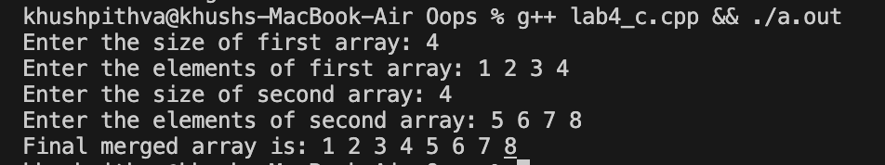
Practical No: 4(d)
AIM: Write a program to search for a number entered by user from
an array of 10 numbers. Sort the array before searching.

Methodology followed:
#include <bits/stdc++.h>
using namespace std;

int main() {
int arr[10];
cout<<"Enter 10 integers:\n";
for (int i = 0; i < 10; i++)
{
cin>>arr[i];
}

sort(arr, arr + 10);

cout<<"Sorted array: ";
for (int i = 0; i < 10; i++)
{
cout<<arr[i]<<" ";
}
cout<<endl;

int target;
cout<<"Enter the number to search: ";
cin>>target;

int low=0, high=9, mid;
bool found=false;

while (low <= high)
{
mid=(low + high) / 2;

if (arr[mid]==target)
{
found=true;
break;
}
else if (arr[mid] <= target)
{
low=mid + 1;
} else {
high=mid - 1;
}
}

if (found)
cout<<"Number "<<target<<" found at position "<<mid + 1<<" (1-based index)."<<endl;
else
cout<<"Number not found in the array."<<endl;

return 0;
}

Output:
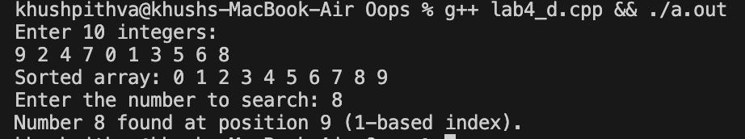
Conclusion:
This practical enhanced our understanding of array operations like input, reversal, merging, sorting, and searching. It also strengthened logic building for finding the second largest element and manipulating arrays efficiently.

